**9 SCIENCE 2014**

### BIOLOGY TEST TWO

Name: ____________________ Teacher: ___________________ Mark: /50

**Percentage: %**

**SECTION A: MULTIPLE CHOICE (15 marks)**

**Please answer on the multiple choice answer grid below.**

1. A B C D 10. A B C D

2. A B C D 11. A B C D

3. A B C D 12. A B C D

4. A B C D 13. A B C D

5. A B C D 14. A B C D

6. A B C D 15. A B C D

7. A B C D

8. A B C D

9. A B C D

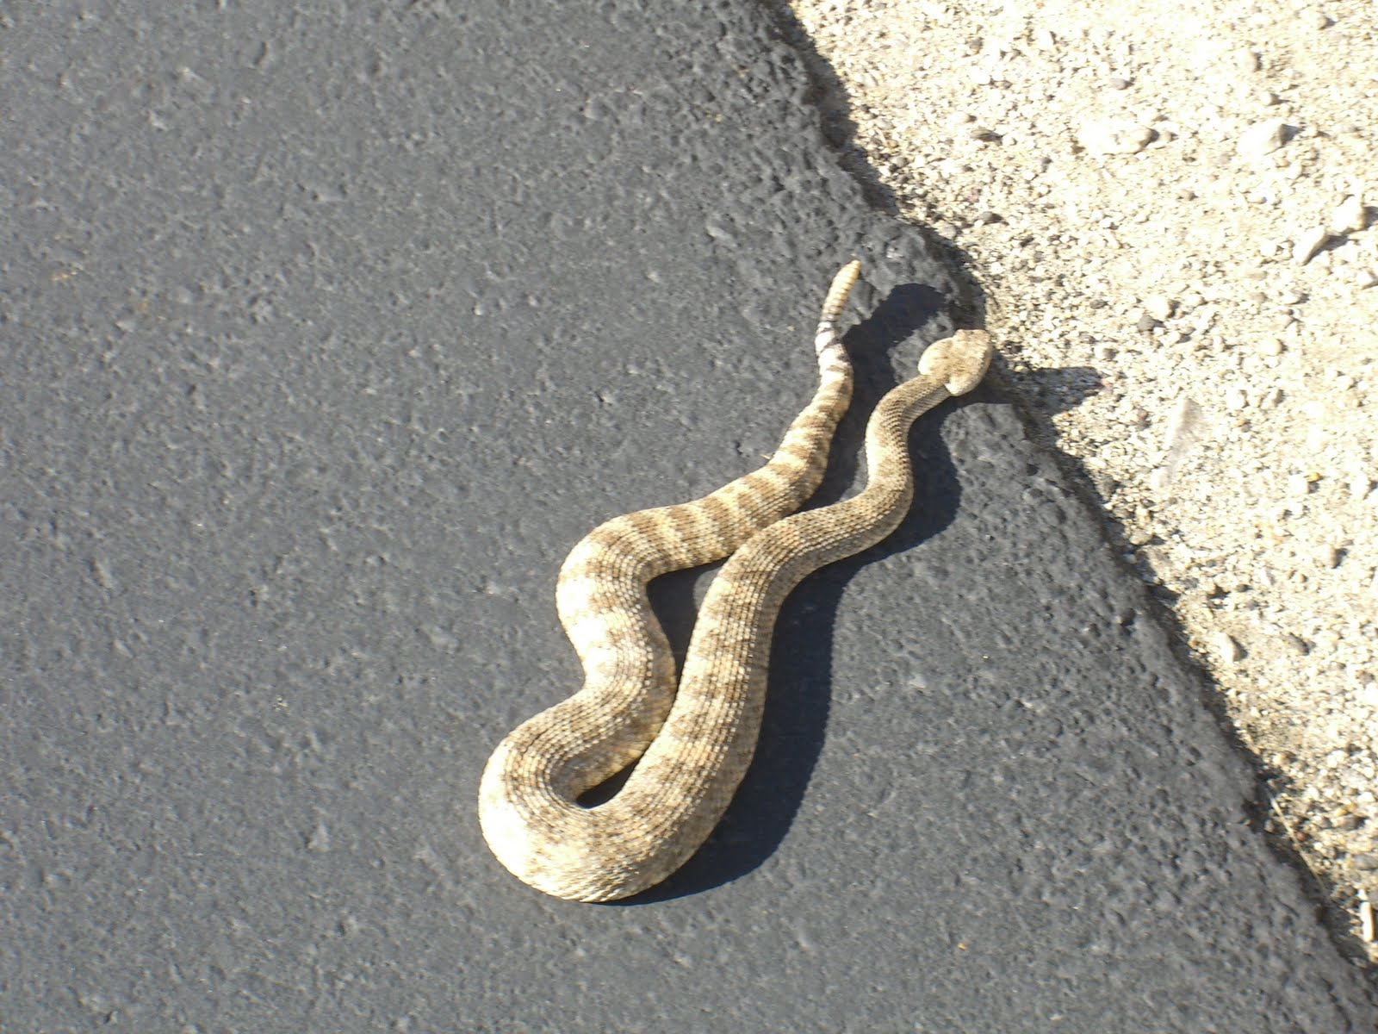1. The snake lying in the sun on the road is an example of an:

(a) endothermic organism.

(b) andothermic organism.

(c) ectothermic organism.

(d) exothermic organism.

2. Choose the correct term that means ‘a list of all the factors in an organisms’ surroundings that affect it’.

(a) Habitat.

(b) Biomass.

(c) Ecosystem.

(d) Environment.

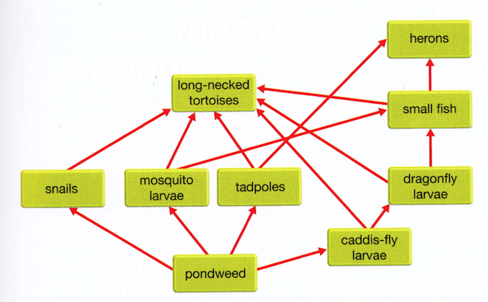Question 3-6 are based on the food web on the right.

3. Identify which of the following relationships in the table are correct.

|  |  |  |
| --- | --- | --- |
| Answer | Predation | Competition |
| (a) | Small fish and mosquito larvae | Tadpoles and dragonfly larvae |
| (b) | Snails and pondweed | Heron and small fish |
| (c) | Heron and small fish | Heron and long-necked tortoise |
| (d) | Long-necked tortoise and tadpoles | Tadpoles and small fish |

4. If the lake was sprayed to control mosquitos, identify the most likely effect.

(a) The biomass of pondweed would decrease.

(b) The tadpole population would decrease.

(c) Most of the herons would migrate out of the area.

(d) The population of small fish would decrease.

5. If a disease killed most of the long-necked tortoises, identify a likely short-term change in the ecosystem.

(a) Rapid increase in the numbers of small fish.

(b) Decrease in the numbers of heron.

(c) Rapid increase in the biomass of pondweed.

(d) No change in the biomass of caddis-fly larvae.

6. Identify which of the following is a correct pyramid of biomass that could be drawn for this ecosystem.

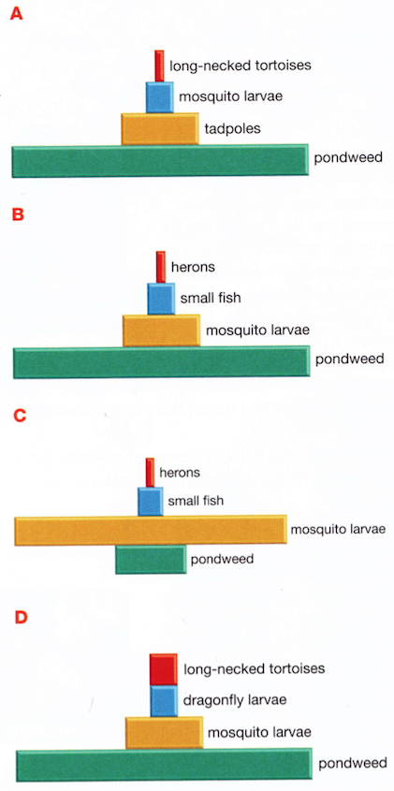

7. Select the abiotic factors below:

(a) temperature, predation, water.

(b) competition, soil type, fire.

(c) water, fire, temperature.

(d) soil type, parasites, sunlight.

8. Your body sweating when you are hot is an example of:

(a) a functional adaptation.

(b) a behavioural adaptation.

(c) a structural adaptation.

(d) an environmental adaptation.

9. A bat having wings is an example of:

(a) an environmental adaptation.

(b) a behavioural adaptation.

(c) a functional adaptation.

(d) a structural adaptation.

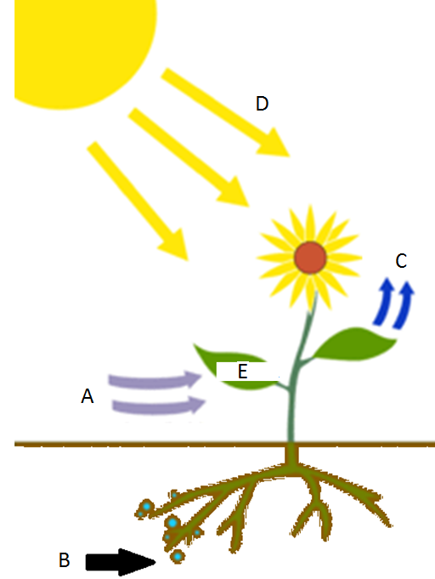Questions 10-12 are based on the diagram on the right.

10. Choose the correct statement below.

(a) ‘A’ refers to carbon dioxide.

(b) ‘A’ refers to oxygen.

(c) ‘A’ refers to nutrients.

(d) ‘A’ refers to sunlight.

11. Choose the correct statement below.

(a) ‘B’ refers to water.

(b) ‘B’ refers to oxygen.

(c) ‘B’ refers to nutrients.

(d) ‘B’ refers to carbon dioxide.

12. Choose the correct statement below.

(a) ‘E’ refers to glucagon.

(b) ‘E’ refers to glucose.

(c) ‘E’ refers to oxygen.

(d) ‘E’ refers to glycogen.

13. Mutualism is a relationship between two organisms where:

(a) both organisms are harmed or killed.

(b) one organism benefits and the other neither benefits or is harmed.

(c) one organism benefits and the other is harmed or killed.

(d) both organisms benefit.

14. The range of different species in a community is known as:

(a) community.

(b) biodiversity.

(c) speciation.

(d) collaborators.

15. This mosquito sucking the blood of a human is an example of:

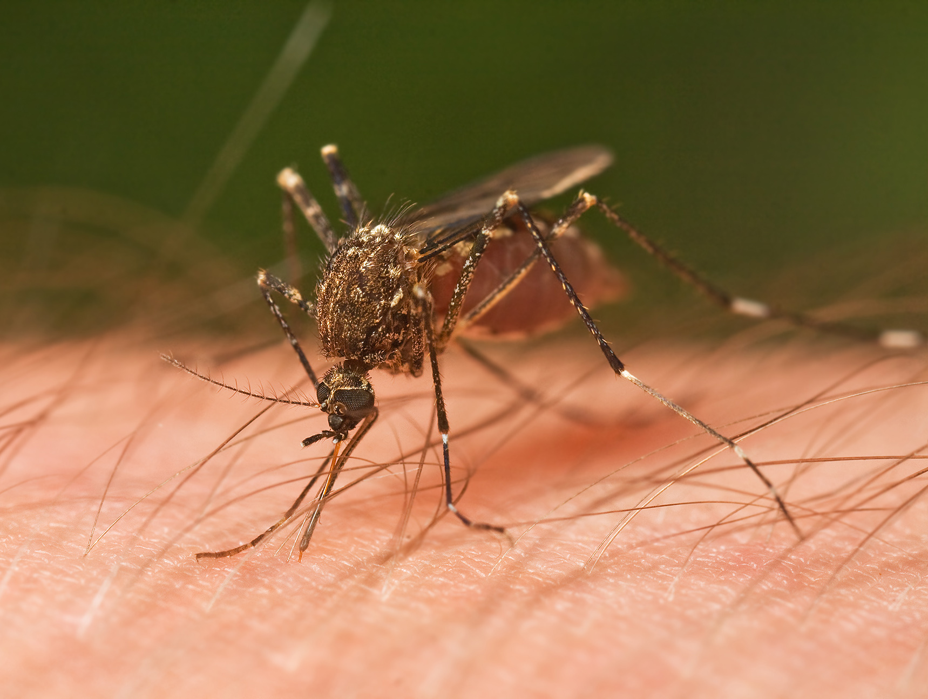

(a) commensalism.

(b) mutualism.

(c) parasitism.

(d) predation.

**SECTION B: SHORT ANSWER (35 marks)**

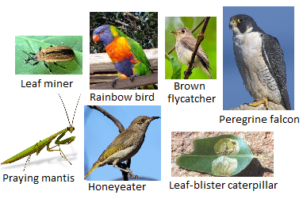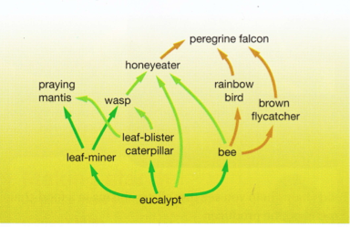**1.** Look at the food web below and answer the following questions. (9 marks)

**a.** State the name of the producer: ___________________________________________________

**b.** State the name of a herbivore: ____________________________________________________

**c.** State the name of two first-order consumers:

_____________________________________________________________________________________

**d.** State the name of two carnivores:__________________________________________________

**e.** State the name of two third-order consumers:

_____________________________________________________________________________________

**f.** List three different food chains containing the peregrine falcon:

**g.** List three animals that compete for bees as a food source:

_____________________________________________________________________________________

**h.** List two animals that compete for leaf-miners as a food source.

_____________________________________________________________________________________

**i.** Write an example of a predator and prey.

Predator: __________________________ Prey: _____________________________

**2.** Explain the difference between the environment and the habitat of an organism.(2 marks)

_____________________________________________________________________________________

_____________________________________________________________________________________

_____________________________________________________________________________________

_____________________________________________________________________________________

**3.** Write the word equation for photosynthesis. (2 marks)

**4.** List the two decomposers found in ecosystems. (1 mark)

_____________________________________________________________________________________

**5.** Describe two reasons why decomposers are vital for ecosystems to keep functioning. (2 marks)

_____________________________________________________________________________________

_____________________________________________________________________________________

_____________________________________________________________________________________

_____________________________________________________________________________________

**6.** Answer the true/false questions below (circle your answer). (2 marks)

a. Energy does not cycle through ecosystems like matter does. True False

b. Energy flow through food chains results in energy losses. True False

c. Matter is not able to cycle in ecosystems. True False

d. The total mass of organisms decreases at each successive stage of a food chain. True False

**7.** Explain why food chains are short and are unable to have more than just a few organisms. (2 marks)

_____________________________________________________________________________________

_____________________________________________________________________________________

_____________________________________________________________________________________

_____________________________________________________________________________________

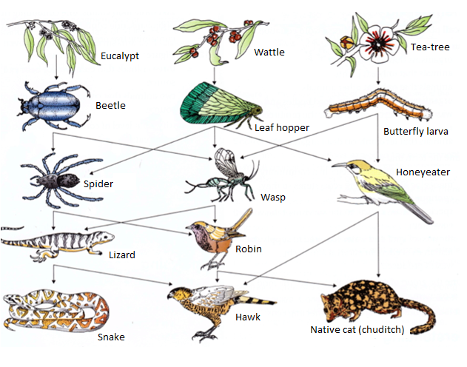**8.** Look at the food web and answer the following question.

(8 marks)

If the amount of wattle increased, describe what you think would happen to each of the following populations and explain why.

**a.** Leaf hoppers: __________________________________________________________________

_____________________________________________________________________________________

_____________________________________________________________________________________

_____________________________________________________________________________________

_____________________________________________________________________________________

**a.** Wasps: _______________________________________________________________________

_____________________________________________________________________________________

_____________________________________________________________________________________

_____________________________________________________________________________________

_____________________________________________________________________________________

**c.** Honeyeaters: __________________________________________________________________

_____________________________________________________________________________________

_____________________________________________________________________________________

_____________________________________________________________________________________

_____________________________________________________________________________________

**d.** Beetles: _______________________________________________________________________

_____________________________________________________________________________________

_____________________________________________________________________________________

_____________________________________________________________________________________

_____________________________________________________________________________________

|  |  |
| --- | --- |
| Invasive species | Number of mammal species  that were threatened |
| Rabbits | 11 |
| Pigs | 2 |
| Cats | 24 |
| Foxes | 20 |
| Goats | 4 |

**9.** In Australia, in 2002, the number of mammal species that were threatened by invasive animals was recorded. The table on the right shows the data recorded.

**a.** What type of graph would be suitable for this data, a bar graph or line graph? Explain your answer. (1 mark)

_____________________________________________________________________________________

_____________________________________________________________________________________

**b.** Draw a graph using the data in the table. (6 marks)

